**Who will visit your site? Potential employers, new clients or customers?**

The site will be a portfolio site, goal is to eventually sell paintings, but for now I will be happy with just having them out there, people can look at them

**What can make you and your product stand out against competitors?**  
Lovely, clean site that changes often, simple, not cluttered.

**How would you speak to your clientele if you were communicating in person? How could you translate that style and tone**

**Digitally?**

If I'm looking at paintings on a portfolio site I think I'm first attracted by color or an interesting image, big.  
  
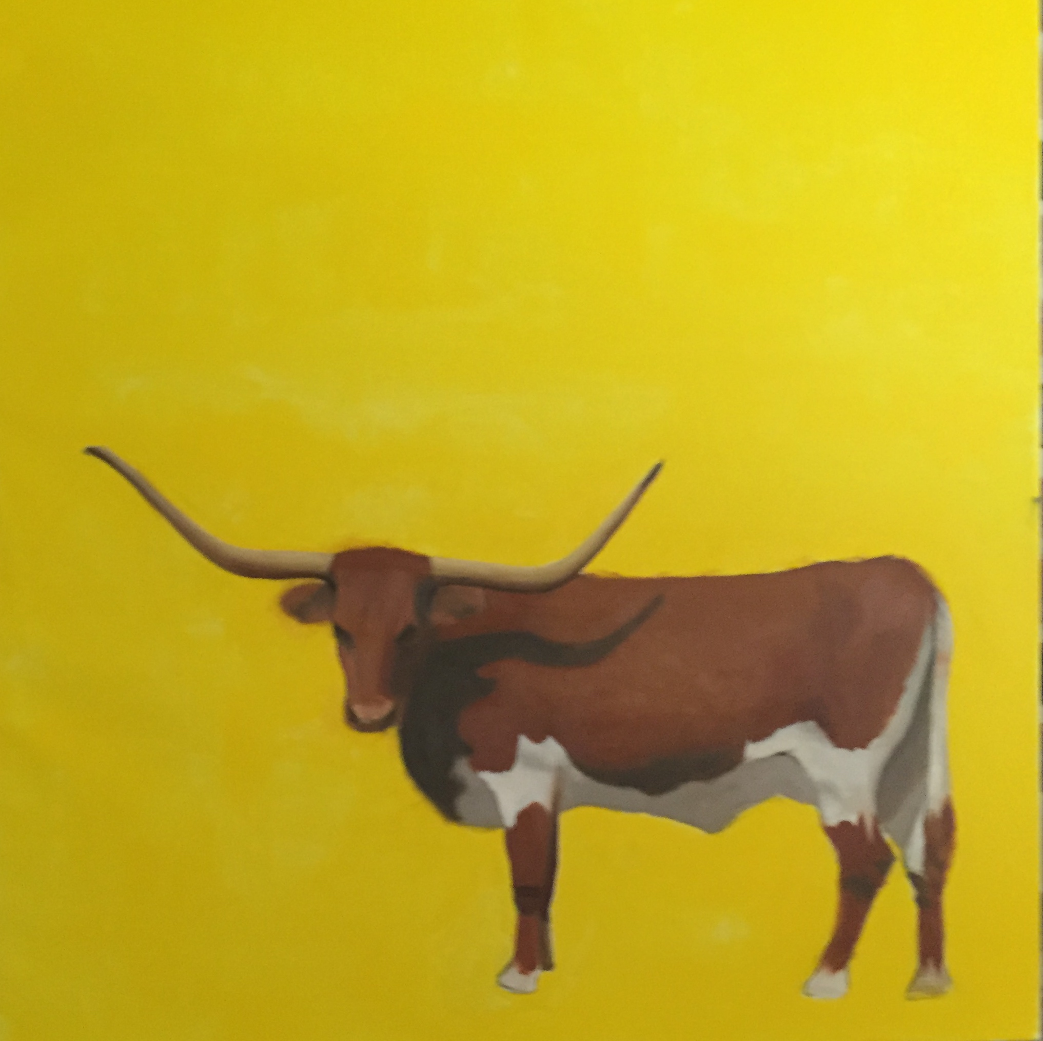All the images that I have won't fit one cohesive unit. Hmmm. May have to limit what I use and paint for site.

Homepage:

Contains:

Title

Navigation

Logo

**shanna scott**

Work:

Paintings

Pages of site:

Front page

About me

Abstract

Traditional

Cattle?? Animal